Downloading Citrix Receiver for Windows
Heartland Community College – Information Technology
Version 2.0 – 1/09/2015

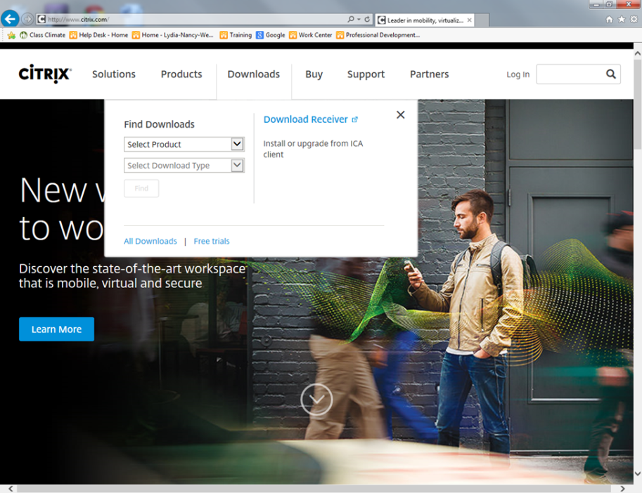
- Go to www.citrix.com and choose “Downloads”

- Click on “Download Receiver”

- Click “Download Receiver for Windows”
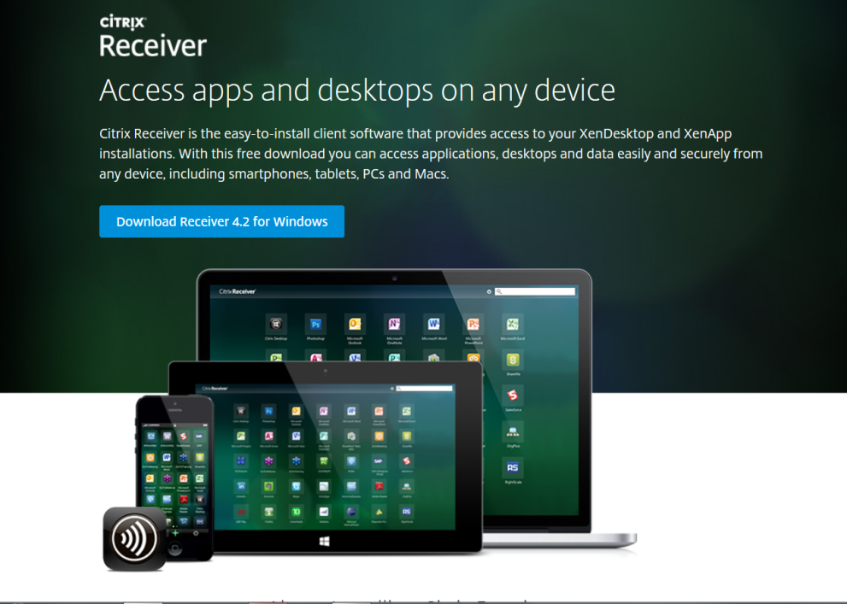

- Click “Run” at the bottom if prompted.
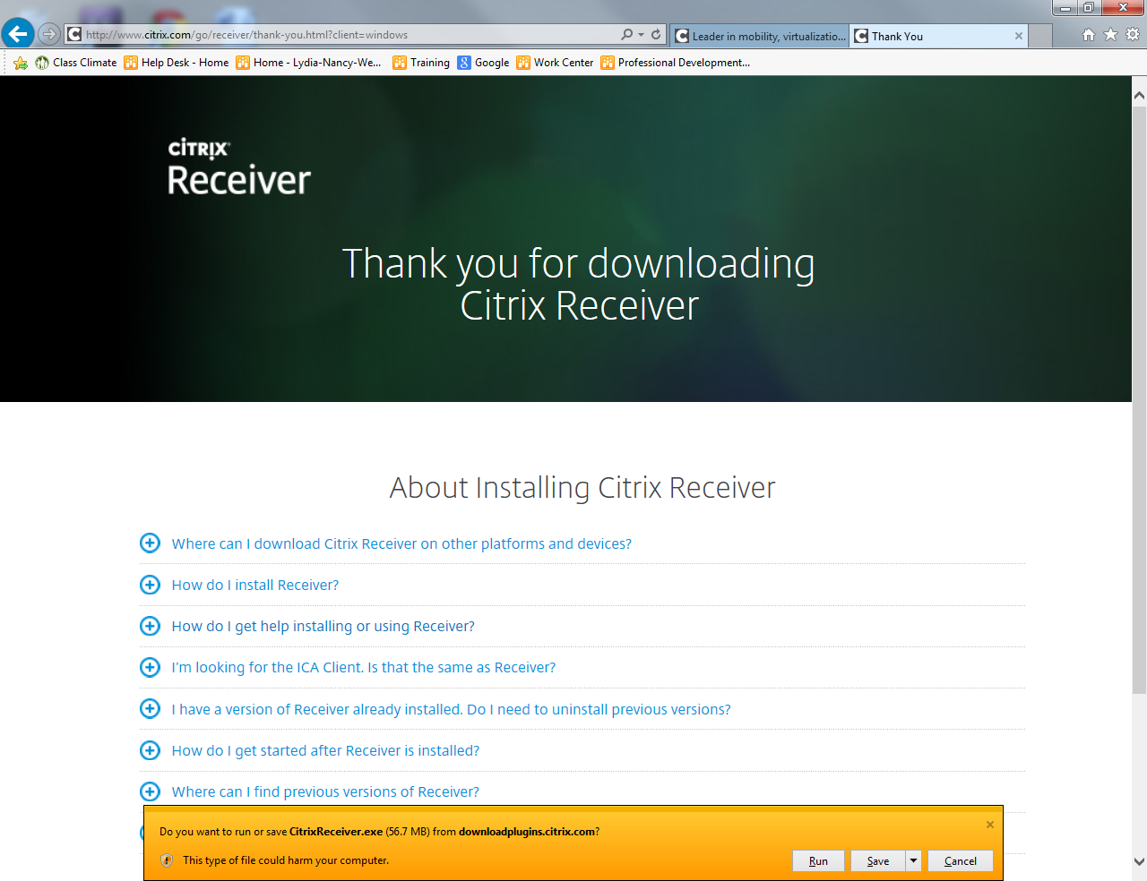
- Click “Yes” to allow it to run if prompted
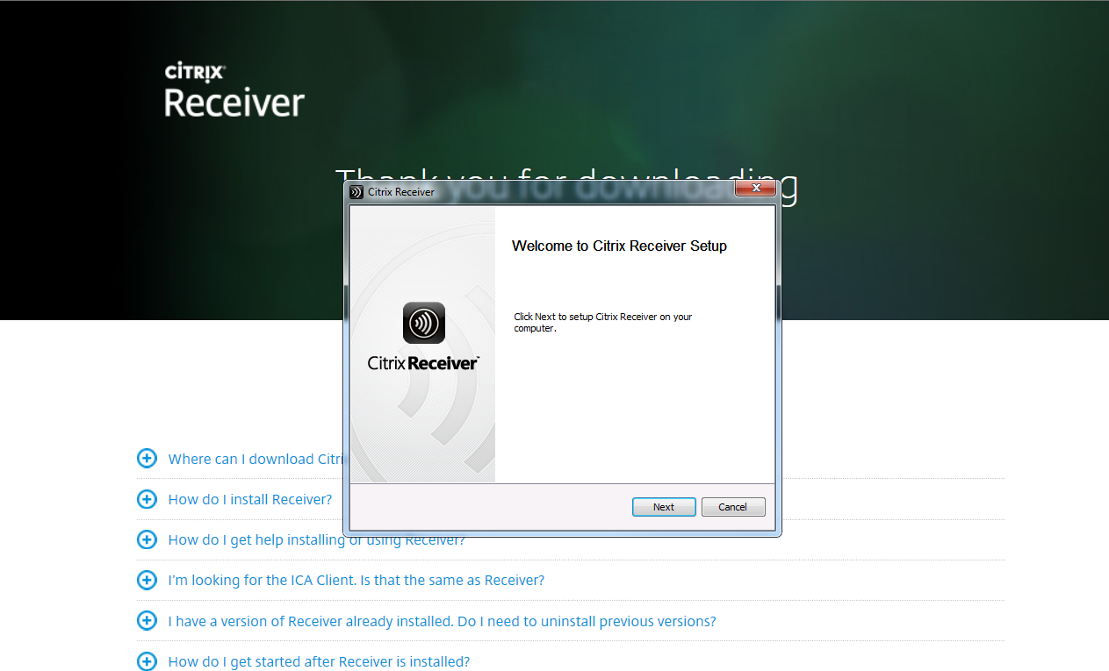
- Click “Install” to install the Citrix Receiver

- Click “I Agree” and click “Continue”

- In the address bar of the web browser type in the following address:
https://ctxapps.heartland.edu/citrix/storeweb

- If prompted, choose to “Allow Add-on” and click “Allow”
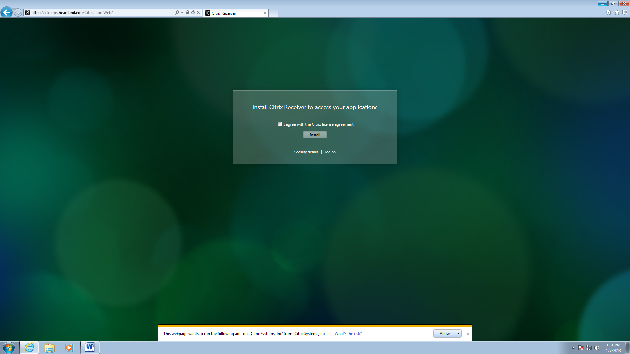
- Log in with your Heartland login name and password.
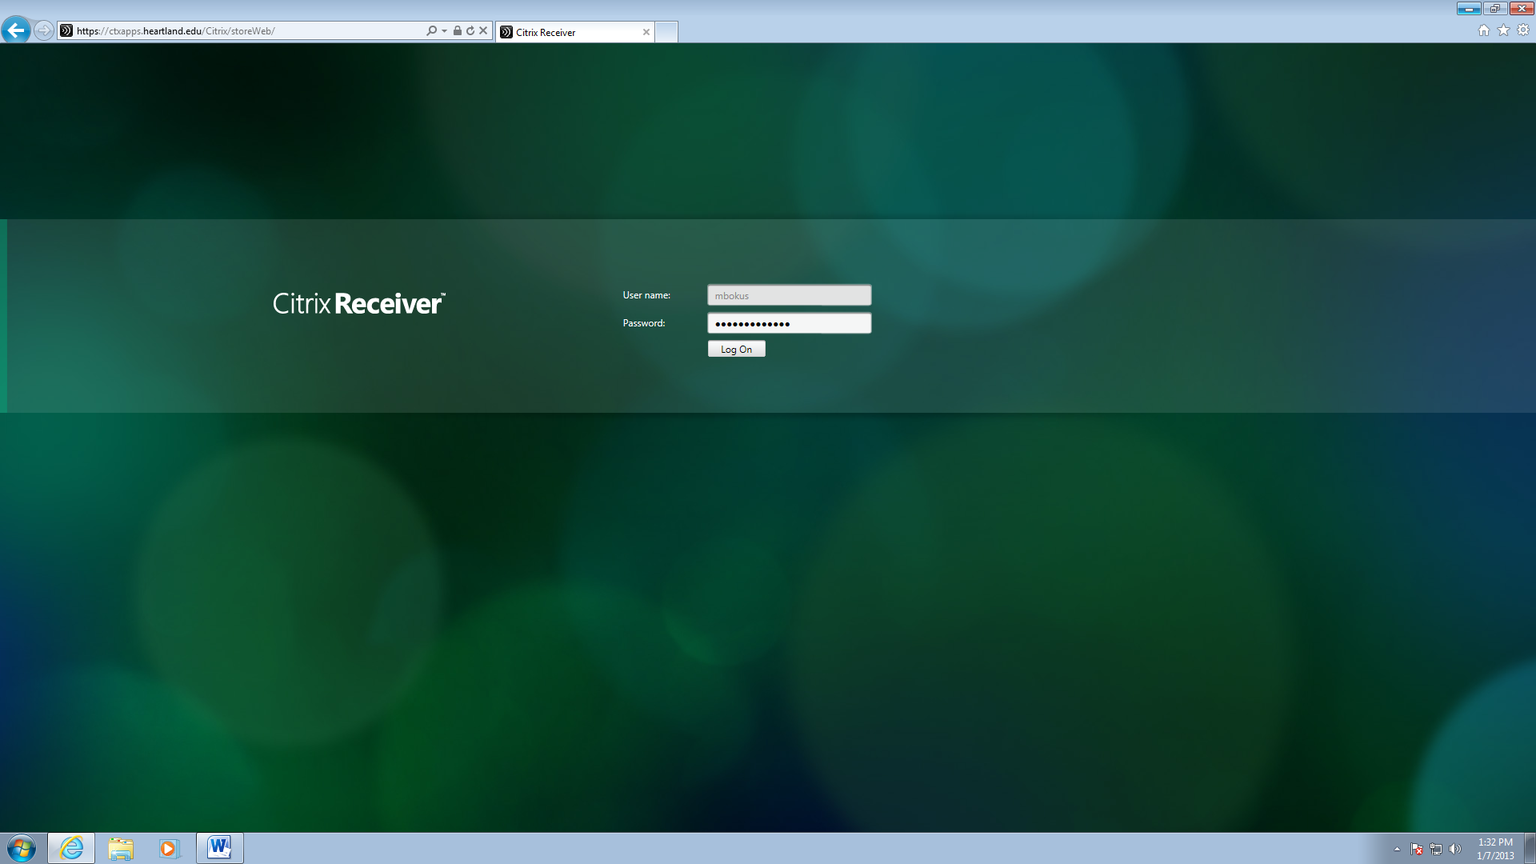

- In the upper-right corner of the screen, click the down arrow next to your name and choose “Activate”.
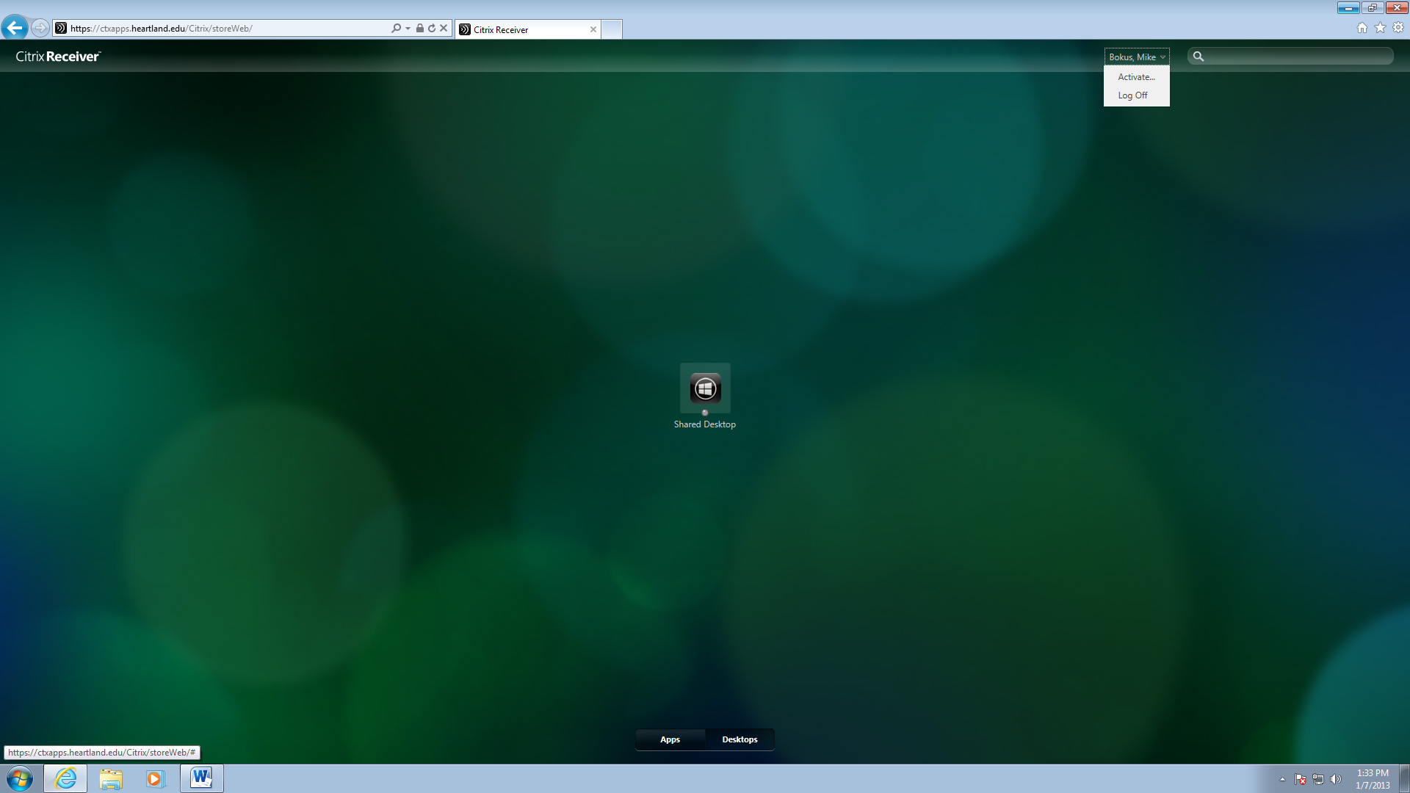
- Choose “Open” if prompted, then click “Add” in the dialog box that appears.
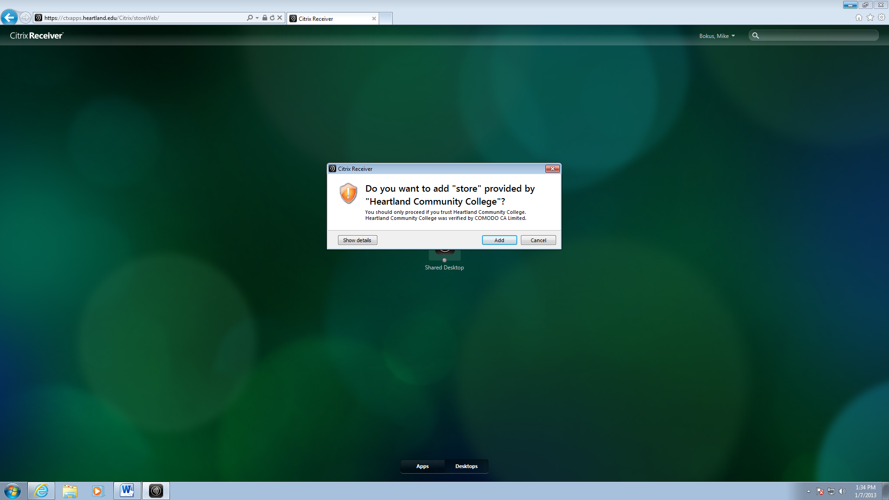

- Enter your login name and password in the login box again and click “Log On”
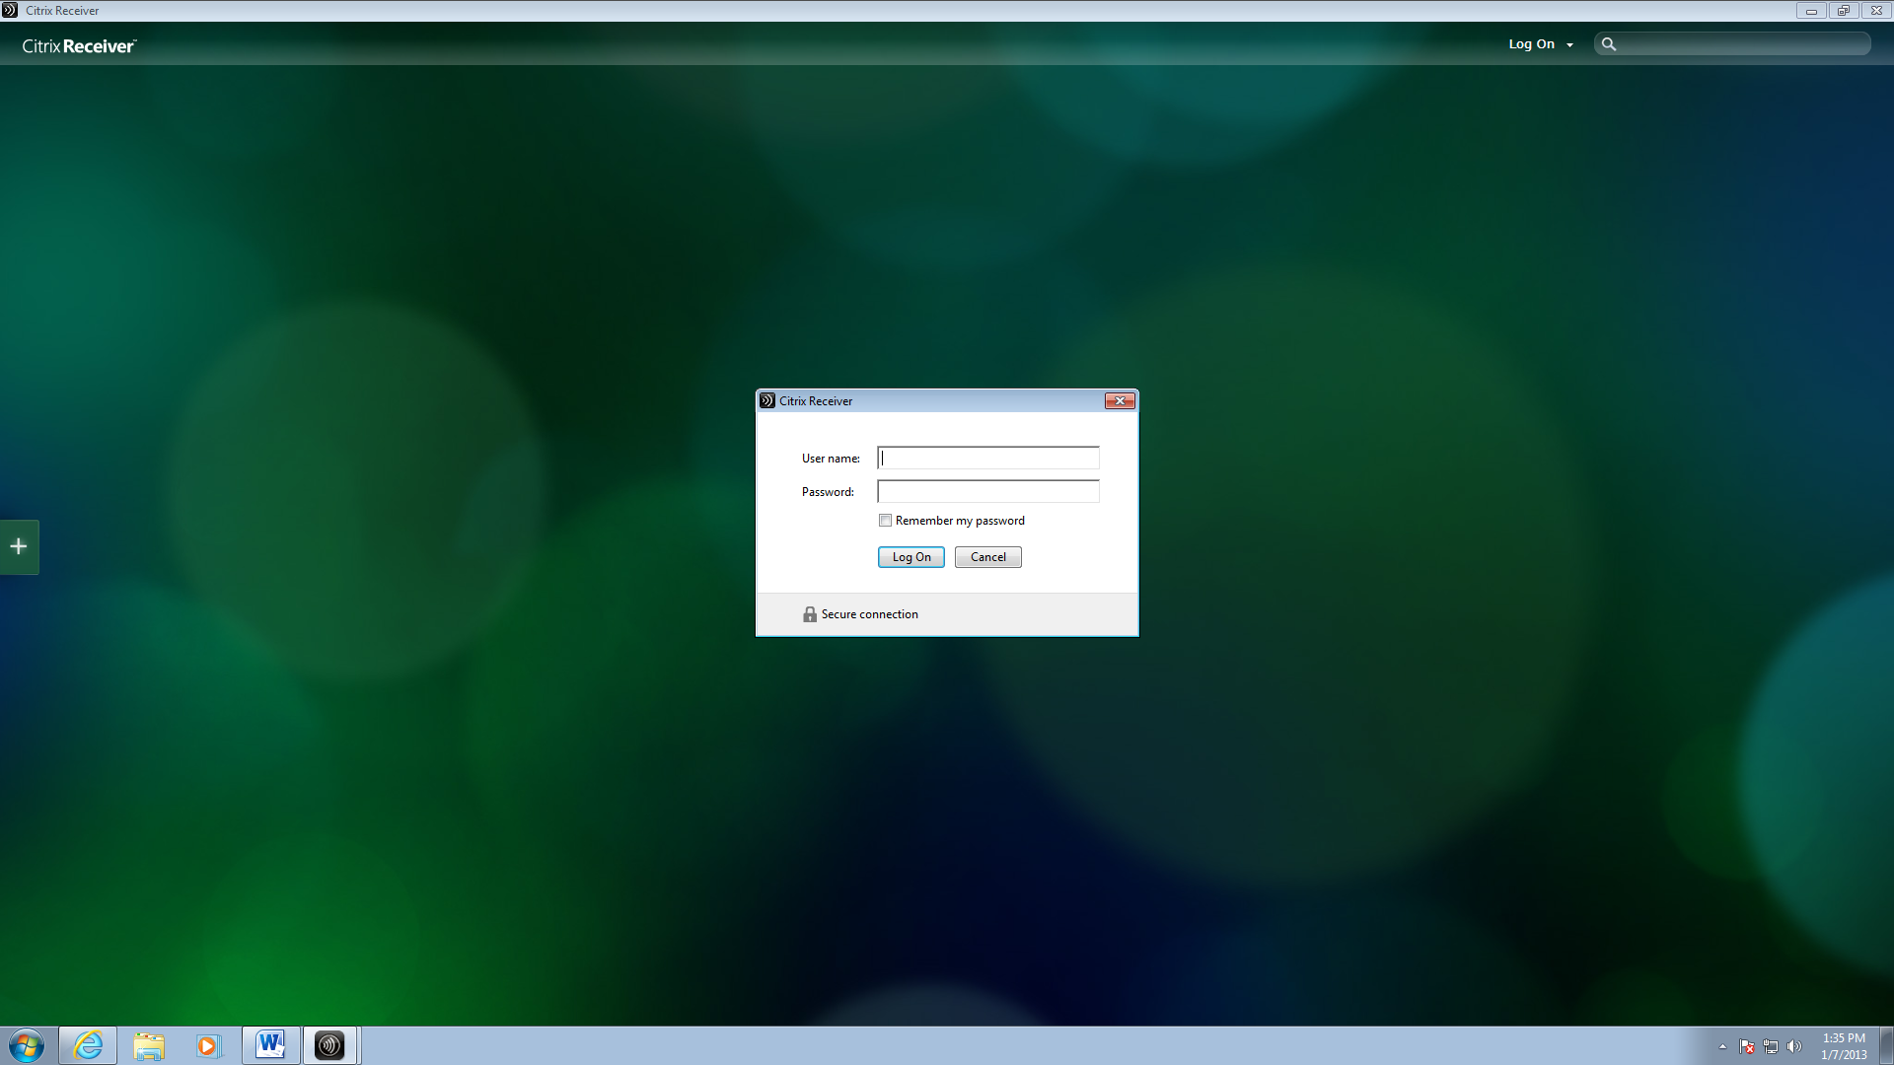
- Click on “Shared Desktop” to start using the Citrix Shared Desktop
